**END OF TERM TWO GEOGRAPHY ASSESSMENT**

**S.1**

**Instructions.**

**Answer all items in this paper**

**TIME. 2 HOUR**

**Item1**

The geography in the places where we live is composed of many living and non-living things big and small all of them important to us. In our interaction with the environment, sometimes the activities we do cause harm to environment. When the environment is destroyed, our existence is also threatened. There is great need to protect it for our survival.

**Support material**.

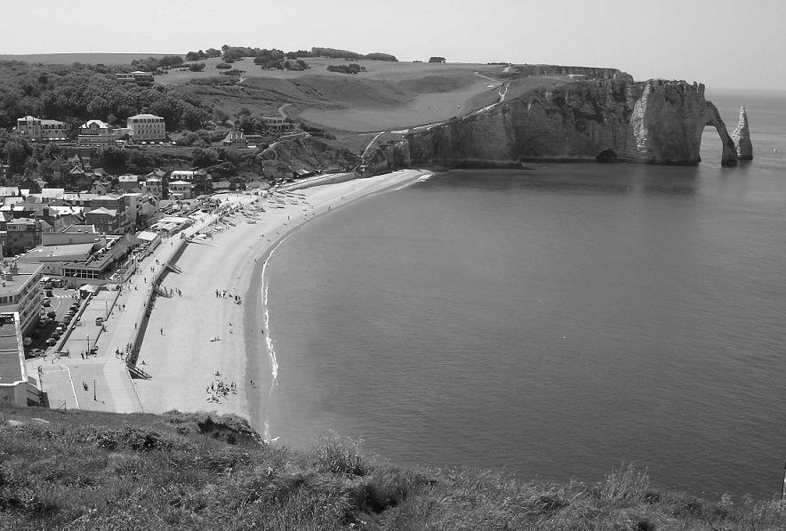

Fig. 1

**Support material: study the Word puzzle bellow to help you do the following tasks..**

|  |  |  |  |  |  |  |  |  |
| --- | --- | --- | --- | --- | --- | --- | --- | --- |
| **V** | **A** | **L** | **L** | **E** | **Y** | **D** | **C** | **E** |
| **M** | **E** | **S** | **V** | **I** | **W** | **F** | **T** | **A** |
| **T** | **E** | **O** | **C** | **U** | **B** | **I** | **O** | **C** |
| **U** | **R** | **I** | **V** | **E** | **R** | **U** | **U** | **L** |
| **C** | **K** | **L** | **T** | **F** | **N** | **A** | **D** | **I** |
| **O** | **L** | **B** | **H** | **I** | **L** | **L** | **E** | **F** |
| **A** | **M** | **U** | **T** | **S** | **E** | **A** | **E** | **F** |
| **S** | **U** | **N** | **I** | **A** | **R** | **I** | **M** | **A** |
| **T** | **D** | **B** | **E** | **A** | **C** | **H** | **N** | **G** |

Fig. 2

**Task:**

1. Study the word puzzle above and write 8 physical features that can be found in an environment (8scores)

Item 2

Chemutai Nakagiri in his career of studying Geography to become a pilot visited a meteorological station and found the following instruments. **Mercury Barometer**, **Hygrometer**, **wind vane, Rain Guage, wind sock, Campbell sunshine recorder**,

Task: choose only 2 instruments and describe how it measures the element of weather( also include the diagram) (8 scores)

Item 3

The Uganda National Meterological society always provides predictions of weather and climate by producing climatic statistics to the public most especially farmers , this helps farmers to prepare for seasons , however some famers cannot interpret the provided statistical information.

1. As a senior one student, Prepare a suitable graph that will be presented to the local farmers from the statistics below. Such that farmer are in position to interpret the information and improve crop productivity (10 scores)

***Table 1***

|  |  |  |  |  |  |  |  |  |  |  |  |  |
| --- | --- | --- | --- | --- | --- | --- | --- | --- | --- | --- | --- | --- |
| Month | **J** | **F** | **M** | **A** | **M** | **J** | **J** | **A** | **S** | **O** | **N** | **D** |
| Tem[ (0c) | 21 | 21 | 21 | 21 | 21 | 20 | 21 | 22 | 22 | 22 | 21 | 21 |
| R/fall (mm) | 147 | 158 | 249 | 356 | 316 | 86 | 48 | 86 | 107 | 132 | 161 | 193 |

1. For good preparation of the season, help the farmers to calculate the following: -

* Mean annual rainfall (2 scores)
* Mean annual temperature ( 2 scores)
* Annual temperature range (2 scores)

END